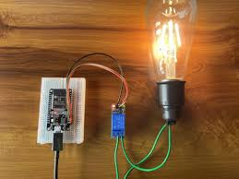

Write up
  - ESP32 LIGHT AUTOMATION
AJITH BIJU |ESP32 PROJECT| 21/05/2026
ESP32 Based IoT Home Automation Project Report 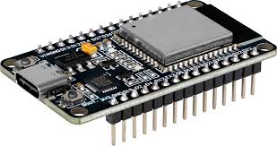
Introduction
The rapid development of Internet of Things (IoT) technology has changed traditional electrical systems into smart and automated systems that can be controlled remotely. This project explains the design and implementation of an IoT-based smart light control system using ESP32 and the Blynk cloud platform. The system allows users to control an electrical bulb remotely using a mobile application through wireless internet communication.
In this project, the ESP32 acts as the main controller and edge computing device, while the relay module is used to safely control the bulb. The main significance of this project is that it improves convenience and reduces manual effort by enabling remote appliance control. It also helps in energy efficiency because appliances can be monitored and controlled easily. Nowadays, similar technologies are widely used in smart homes, industries, security systems, and modern automation applications. This project also provides practical knowledge about how IoT devices communicate with cloud platforms in real time
.
1. IoT (Internet of Things)
Internet of Things (IoT) is a modern technology in which physical devices are connected to the internet to collect, exchange, and process data automatically. These devices communicate with each other using sensors, microcontrollers, communication networks, and cloud platforms without requiring continuous human interaction.

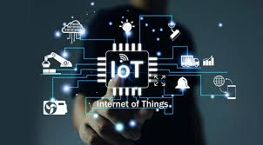
In this project:
- The ESP32 acts as the IoT device.
- The Blynk application acts as the user interface.
- Wi-Fi provides internet connectivity.
- The relay module controls the bulb.
IoT Architecture of the Project
1. Device-to-Device (D2D)
In these devices communicate directly with each other.
No cloud is required sometimes.
Example: - Bluetooth, Zigbee, Wi-Fi Direct
2. Device-to-Cloud
In this Devices connect directly to cloud servers through internet.
Example: -Wi-Fi, GSM, Ethernet
3. Device-to-Gateway
Devices communicate through a gateway device.
Gateway acts like a middleman.
example: -Smartphone, Router, Raspberry Pi
Layers of IoT Architecture
- perception layer
It is the layer which consists of all the physical sensors and devices that is used to gather data. The sensors are used to measure temperature, motion, light etc.
They convert physical activities into digital signals that can be transmitted.
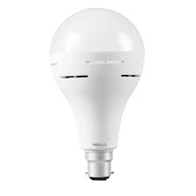
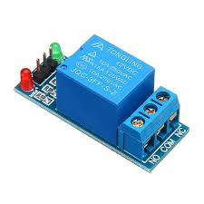
This layer contains:
ESP32 microcontroller
Relay module
Bulb
The ESP32 collects commands from the cloud and controls the relay accordingly.
- Network Layer
It is responsible for transmitting data from sensors to processing centers.it uses technologies like Wi-Fi , Bluetooth ,mobile network .it ensure secure and reliable delivery of data cross the network.
This layer handles communication between devices using:
Wi-Fi
TCP/IP protocol
The ESP32 connects to the local Wi-Fi router and exchanges data with the Blynk cloud server.
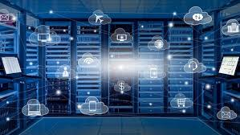
- Middleware Layer
It handles the processing, storage and management of data.it uses cloud servers provide the storage and other facilities for this layer. Here data is stored in databases analyzed using software tools and the data is organized for easy access.
The Blynk cloud server:
Stores device information
Transfers commands between mobile app and ESP32
Maintains communication sessions
- Application Layer
It is the layer where the user interacts with the data .It includes websites mobile apps ,etc that is used to display information and allow the user to control devices.
For example:-

The Blynk mobile application or web console allows the user to:
Turn the bulb ON/OFF
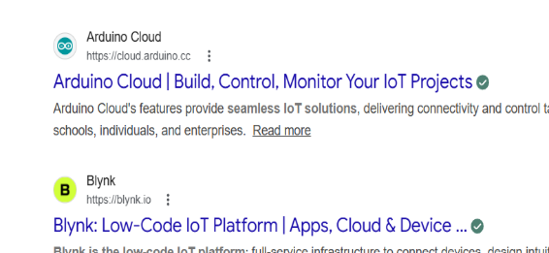
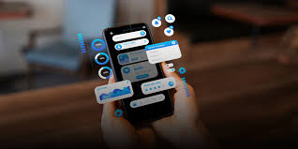
Monitor device can be used remotely

OSI System and IoT
The OSI (Open Systems Interconnection) model is a framework used to explain how data travels from one device to another through a network.
It divides communication into 7 layers so networking becomes easy to understand and troubleshoot.
7 Layers of OSI Model
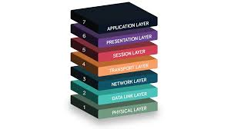
1. Physical Layer
This layer sends raw electrical signals or wireless signals.
Example
Electrical signals traveling through Ethernet cable.
2. Data Link Layer
This layer checks whether data goes to the correct nearby device.
It Uses MAC addresses to communicate to communicate with each other.it is a unique code that is implanted in device.
3. Network Layer
This layer decides the path for data.
Uses: -IP addresses, Routing
Example-Routers
4.Transport Layer
This layer ensures complete and correct delivery.
Protocols used-TCP UDP
- Session Layer
This layer creates and manages connection between devices.
Example
Maintains connection during video call.
- Presentation Layer
This layer converts data into readable format.


Example

7.Application Layer
It is the application that is used by people
Examples-Email, WhatsApp etc
Data transmission using OSI model
1.APPLICATION LAYER
It is used by applications which use network to communicate.
For example:-
There are many application protocols that is used for various purpose .All these protocols forms the application layer.
For ex:-file transfer uses ftp protocol
Web searching uses http/https protocol
Emails:-smtp protocol
2.Presentation layer
Presentation layer receives data from application layer. This data is in the form of characters or numbers.
Ex:-hello,25haf
translation
In this layer these characters and numbers are converted into binary numbers which the computer could understand. For ex:-Hi to 11001000 11001001This process is called translation

compression
11001000 11001001 can be reduced into small number of bits 11001001.this process is called data compression
It reduces the size of the data and helps to transfer data faster.
Ex-10mb data is reduced to 5mb
Therefore, it can be used for real time video and audio streaming
Encryption/decryption
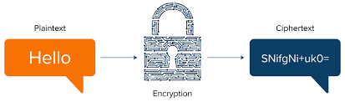
To maintain the integrity of data before transmission data is encrypted.it enhances the security of data.
In sender side data is encrypted and in receiver side data is decrypted
This encryption/decryption uses SSL protocol(secure sockets layer)
3.Session layer
Session layer uses APIs(application programming interfaces)
NETBIOS is an example of APIs which allow applications to communicate which each other
Before a session is established ,server performs a function called authentication.
It is a process of verifying who you are .for this it uses a user name and password. If it is matched a session is established between the client and the server
Next the authorization is checked.it is used to determine that if the user have the permission to access the file.
It keeps the track of the file that are downloaded.
For example-when u access a data from a web page it keeps track of the file that u r accessing
4.Transport layer
It controls the reliability of communication through segmentation, flow control, error control .
Segmentation
In segmentation data received from session layer is divided into small data unit called data packets.
Each data packet has a source and destination port number and sequence number
Port number helps to direct the packets to the required application
Sequence number helps to reassemble the packets in the correct order.
For example:-data packet 1
Data packet 2
Data packet 3
Flow control
It controls the amount of data transmitted to a level receiver can process
For example:-when a mobile is connected toa server .here sever can transmit data at 100mbps and mobile can process data at 10mbps .here the mobile with the help of the transport layer can request the server to send the data at 10mbps.
Error control
If some data packet doesn’t reach the destination transport layer uses automatic repeat request to retransmit the lost data packet.
It uses protocols like:-
Transmission control protocol(TCP):-it performs connection-oriented transmission
User datagram protocol(UPD):-it performs connectionless transmission
UDP is faster than TCP because it doesn’t have feedback.

5.Network layer
It is used for transmitting of a data packet from one device to another located in different networks. Each segment in network layer is called data packet.
Here we use routers for communication
The functions of networking layers are:-
Logical addressing
Ip addressing done in logical layer are called logical addressing. Every computer connected to a network have a unique Ip address.in this layer it assigns sender and receiver Ip address each data packet so that it ensures the data packet is sent and received correctly
Routing
It is a method of moving a data packet from source to destination
For example:-if we need to access YouTube, we send request and the router checks the source and destination Ip address to deliver the item.

Path determination
A computer connected to network can deliver data in many ways. Choosing the best path for determination is called path determination
It uses protocols like :-OSFP (open shortest path first),BGP (border gateway protocol)to determine best path to deliver data.
6.Data link layer
it receives data packet from the network layer which contain the Ip address of sender and the receiver
there are two types of addressing:-
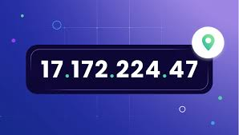
logical addressing
it is done at network layer where we assign sender and receiver Ip address to each data packet
physical addressing
physical addressing is done at the data link layer where mac address of both the devices is assigned to each data packet.
mac address is unique code embedded in the NIC of the computer when it is manufactured.
The NIC is used to transfer data from one computer to anther through a local media. Local media radio signals used for means the copper wire fiber cables radio signals used for transmission.
7.Physical layer
Physical layer is used for converting the binary sequence into signals and transmit over local media.it can be electrical ,light or radio signals.
Signal generated by the physical layer depend on the type of media used to connect two devices
At the receiver ,the physical layer receives signal convert it into bits and pass it to data link layer as a frame and the two higher layers finally to the application layer. application layer protocol makes the senders message visible in the application in the receiver’s computer screen.
Example

1. Application Layer
The process starts at the application layer.
When a user types an email in Gmail and clicks Send, the application layer prepares the email data for transmission.
Protocols used:
HTTP/HTTPS for web access
SMTP (Simple Mail Transfer Protocol) for sending emails
For example:
User types: Hi
The application layer passes this message to the next layer.
2. Presentation Layer
The presentation layer handles:
Translation
Compression
Encryption
Translation
The text message is converted into binary form that the computer understands.
Example: Hi to Binary format
Compression
The binary data is compressed to reduce the size of the data.
Example:
10 MB file to compressed to 5 MB
Encryption
Before transmission, Gmail encrypts the data for security.
The encrypted data is then passed to the session layer.
3. Session Layer
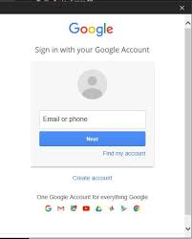
The session layer establishes and manages communication between the sender and the Gmail server.
Authentication
The Gmail server checks:
Username
Password
If correct, a session is created between:
Client (user device)
Gmail server
Authorization
The server checks whether the user has permission to access the Gmail account.
Session Management
The session layer keeps track of: Sent mails
Downloaded attachments
Active communication
APIs such as NetBIOS help applications communicate.
After the session is established, data moves to the transport layer.
4. Transport Layer
The transport layer ensures reliable communication.
Segmentation
The email data is divided into small units called packets.
For Example:
Packet 1
Packet 2

Packet 3
Each packet contains:
Source port number
Destination port number
Sequence number
Port Number
Helps deliver packets to the correct application.
For Example:
Gmail application port
Sequence Number
Helps rearrange packets in correct order at the receiver side.
Flow Control
Controls transmission speed.
For Example:
Gmail server sends data at 100 Mbps
Mobile can process only 10 Mbps
Error Control
If packets are lost during transmission, they are retransmitted using:
Automatic Repeat Request (ARQ)
Protocols used:
TCP (Transmission Control Protocol)
UDP (User Datagram Protocol)
Gmail mainly uses TCP because emails require reliable delivery.
Then the packets move to the network layer.
5. Network Layer
The network layer sends packets between different networks.

Logical Addressing
Each device connected to the internet has a unique IP address.
For Example:
Sender IP address
Receiver IP address
The network layer adds these IP addresses to each packet.
Routing
Routers forward packets from one network to another.
For Example:
When sending Gmail:
Data travels through multiple routers on the internet.
Path Determination
There can be many paths between sender and receiver.
The router chooses the best path using protocols like:
OSPF
BGP
After routing, packets move to the data link layer.

6. Data Link Layer
The data link layer handles communication within the local network.
It adds physical addresses called MAC addresses.
Physical Addressing
Every device has a unique MAC address stored inside the NIC (Network Interface Card).
The data link layer adds:
Sender MAC address
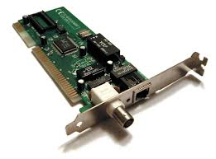
Receiver MAC address
NIC
NIC transfers data through:
Copper cables
Fiber optic cables
Radio signals (Wi-Fi)
At this layer, the data packet is called a frame.
Then the frame moves to the physical layer.

7. Physical Layer
The physical layer converts binary data into signals.
The signals travel through the communication medium to the receiver device.
Receiver Side Process
When the receiver opens Gmail:
- Physical layer receives signals and converts them into bits.

- Data link layer checks MAC address.
- Network layer checks IP address.
- Transport layer rearranges packets using sequence numbers.
- Session layer maintains communication session.
- Presentation layer decrypts and decompresses data.
- Application layer displays the email message in Gmail.
Finally, the receiver sees: Hi on the screen.
2. ESP32 Usage in the Project
The ESP32 is used as the main edge computing device in the project to process commands, control the relay module, connect to Wi-Fi, and enable real-time communication between the hardware system and the Blynk cloud platform.
3. Edge Computing Utilization
Edge Computing
Edge computing is a method that process and stores data closer to where it is created (at the edge of the network).it handles data locally reducing the need to send the data to a central server. So it lowers latency and helps to save bandwidth. Edge servers can filter and prioritize data, giving quick access to information.
Advantages
- Low latency: Faster responses by processing data nearby
- Bandwidth optimization: Less data transfer means lower costs
- Improved reliability: Some apps keep running locally even if the internet drops
Disadvantages
- Limited processing power:- Edge servers aren't as powerful as big data centers
- Network issues:- Communication between edge nodes and the cloud can be unreliable

Cloud computing
Cloud computing is a method of hosting data and applications through the internet in cloud servers or databases allowing users to access them from anywhere in the world.it uses a network of interconnected servers on the internet to provide services. These servers use their resources to serve many users at once
Advantages
- Easy to access:- can access data from anywhere with an internet connection.
- Cost effective:-no maintenance or cost.
- Reliability:- data is host across multiple centers. So, applications will be available even when the hardware fails.
Disadvantages
- Internet dependency: when Internet is lost, we lose the access with the server.
- Data latency: Transferring large amounts of data can cause delays
- Data security: Storing sensitive data remotely can be risky.
Cloud computing is used for:-
- Cloud storage:- Offsite file maintenance
- Cloud applications:- Software can be accessed through a web browser without local hosting (local hosting:- running a website directly on a personal computer online or offline).

4. Latency and Overhead
Latency
Latency refers to the time delay between a user action and the actual response of the device. In IoT systems, lower latency is extremely important for achieving fast and smooth real-time operation.
In This Project Latency occurs during:
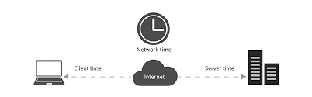
Internet communication
Wi-Fi transmission
Cloud server processing
Factors Affecting Latency
Internet speed
Wi-Fi signal strength
Server response time

Overhead
Overhead refers to the extra communication and processing resources required for transmitting data in a network system.
Types of Overhead
Network overhead
Protocol overhead
Memory overhead
Processing overhead
Overhead in the Project
Examples:
Wi-Fi packet transmission
TCP/IP headers
Authentication tokens
5. Hardware Components
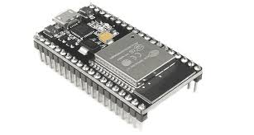
Esp32 acts as the main controller of the project which controls the relay module it switches on /off the bulb.

Specification
The ESP32 operates at 3.3V and is powered using a 5V USB supply. It features built-in Wi-Fi and Bluetooth connectivity, making it suitable for wireless IoT applications and smart automation systems. The board is powered by a dual-core processor running up to 240 MHz, providing fast processing and efficient multitasking capabilities.


relay module :- It is used to switch on/off the bulb.
Specification
he 5V relay module acts as an electrically controlled switch that allows the ESP32 to safely control high-voltage electrical appliances such as bulbs, fans, and other AC loads. It supports trigger voltages from 3.3V to 5V, making it compatible with ESP32 GPIO outputs. The relay can handle loads up to 250V AC at 10A.
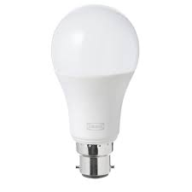
bulb:- it acts as an output device producing light.
Specification
The LED bulb operates on 220V–240V AC with a power rating of 9W and frequency support of 50–60 Hz. It provides bright illumination while consuming significantly less power compared to traditional incandescent bulbs, making it energy efficient and suitable for smart lighting applications. LED bulbs also generate less heat, have a longer lifespan, and offer reliable performance for continuous operation in home automation projects.
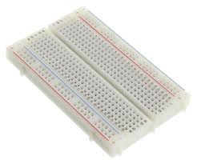
Breadboard:-it is used for assembling the circuit. A breadboard is a reusable prototyping board used for building and testing electronic circuits without soldering. It contains interconnected metal strips beneath the surface that allow components and jumper wires to be easily connected and modified. Breadboards are widely used for circuit design, testing, and educational electronics projects because they simplify assembling temporary circuits.

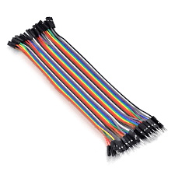
Jumper wire:- it is used to make connections between the components.
Specification
Jumper wires are flexible copper conductor wires used to establish electrical connections between components on a breadboard or prototype circuit. They are commonly available as male-to-male, male-to-female, and female-to-female types
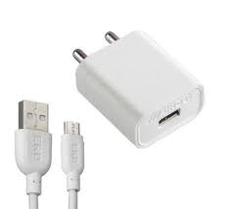
usb power supply:- it is used to supply power to the esp32.
Specification
The USB power supply provides a stable 5V DC output with a current rating of 1A–2A to safely power the ESP32 and other low-power electronic components. It can be supplied using a mobile charger, laptop USB port, or power bank. A stable power source ensures reliable ESP32 operation, proper Wi-Fi performance, and safe functioning of connected modules such as relays and sensors.
6. Software Components
Software Components
Software | Purpose
Arduino IDE | Programming ESP32
Blynk IOT | Mobile Interface
ESP32 Board package | ESP32 programming support
Blynk Library | Cloud communication
WIFI Library | Internet connectivity

8.Data Communication
IP Address
An IP (Internet Protocol) address is a unique number written as four segments separated by dots(.) assigned to every device connected to a network. It acts as a digital mailing address, allowing devices (computers, phones, smart TVs) to locate one another, send data, and communicate across local networks and the internet.
How It Works
When you send an email or visit a website, your device breaks the data into smaller chunks called packets. Each packet is stamped with your IP address (the sender) and the destination IP address (the receiver) so the information routes to the correct place.
The Two Main Types of IP Addresses
- Public IP: Assigned to your home or office router by your Internet Service Provider (ISP). This is your identifier to the outside internet.
- Private IP: Assigned by your router to individual devices on your local network (e.g., your laptop or phone). This allows your devices to communicate with each other privately without being directly exposed to the internet.
Versions of IP Address
- IPv4: The normal format, represented as four sets of numbers separated by dots, like 192.168.0.1.
- IPv6: The newer format, created to handle trillions of devices using an alphanumeric combination of numbers and letters, like 2001:db8:0: 1234:
Domain Name System(DNS)
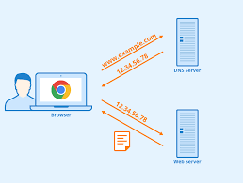
It is a protocol that translates human readable domain names like www.ggogle.com into IP addresses that computers used to locate and communicate over the internet.it allows the users to access the website using easy name instead of complex numbered IP addresses.
For Example: - When you enter a website name like google.com in your browser, the system does not understand the name directly. DNS translates it into an IP address of the server hosting the website. This allows your browser to connect to the correct server and load the webpage.
Data communication protocols
Internet protocol
It is a set of rules and regulations that govern how data is transmitted and received across a network.it defines how a device communicates with each other ensuring that data is sent and received correctly.


HTTP/HTTPS
Hypertext transfer protocol is used for data communication on the web enabling the transfer of webpages from the server to the browser.it operates like a request respond protocol, where the client send a request through web browser to the server for a webpage and the server responds to the request.
https (hypertext transfer protocol secure) is a secure version of the HTTP, which encrypts the data so the data remains secure from outside access.
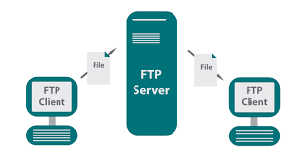
FTP (File Transfer Protocol)
It a network protocol used for transferring files between a client and a server over the internet.it operates on a client server model where the client makes a connection to the server to upload or download files. But ftp doesn’t provide encryption.so for secure file transfer we use FTPS.

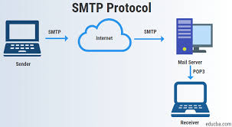
SMTP (Simple Mail Transfer Protocol)
It used for sending and receiving email across a network. Here a client using a Gmail connects to an SMTP sever to send message to a recipient’s mail server.

Wi-Fi Protocol
It is a protocol used for Wi-Fi communication
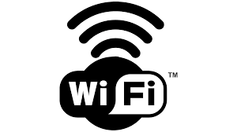
It is used for:-
1.Wireless connectivity
2.Internet communication
3.Cloud access

TCP/IP Protocol
TCP/IP(Transmission Control Protocol/Internet Protocol) is a protocol which enables reliable data transmission by breaking data into packets, ensuring they are send and received correctly and they handle the errors that occurs during the transmission
8. Program
Complete Program Structure
#define BLYNK_PRINT Serial
#define BLYNK_TEMPLATE_ID"TMPL3zlGeCC9M"
#define BLYNK_TEMPLATE_NAME"light iot"
#define BLYNK_AUTH_TOKEN"RvQhItYi4Vndytf80_ZB4e29lNLj85pT"
#include <WiFi.h>
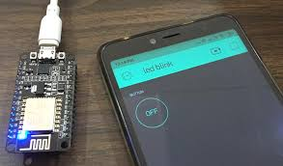
#include <WiFiClient.h>
#include <BlynkSimpleEsp32.h>
char ssid[] = "Redmi 9 Power";
char pass[] = "password";
void setup()
{
Serial.begin(9600);
Blynk.begin(BLYNK_AUTH_TOKEN, ssid, pass);
}
void loop()
{
Blynk.run();
}

9.Program explanation
#define BLYNK_PRINT Serial
- This line enables debugging messages from the Blynk library to be displayed on the Serial Monitor. It helps in checking connection status and errors.
#define BLYNK_TEMPLATE_ID "TMPL3zlGeCC9M"
- This defines the unique Template ID created in the Blynk cloud platform. It identifies the IoT project template.
#define BLYNK_TEMPLATE_NAME "light iot"
- This defines the name of the Blynk template used for the project.
#define BLYNK_AUTH_TOKEN "RvQhItYi4Vndytf80_ZB4e29lNLj85pT"
- This line stores the authentication token provided by Blynk. The token allows the ESP32 to securely connect to the Blynk cloud server.
#include <WiFi.h>
- This header file enables Wi-Fi functionality in the ESP32 and allows connection to wireless networks.
#include <WiFiClient.h>
- This library provides TCP/IP client functions for internet communication between the ESP32 and cloud server.
#include <BlynkSimpleEsp32.h>
- This library contains all functions required for connecting the ESP32 to the Blynk IoT platform.
char ssid[] = "Redmi 9 Power";
- This stores the Wi-Fi network name (SSID) that the ESP32 will connect to.
char pass[] = "password";
- This stores the password of the Wi-Fi network.
void setup()
- The setup() function runs only once when the ESP32 powers ON or resets. It is used for initialization.
Serial.begin(9600);
- Starts serial communication at 9600 baud rate. It allows communication between the ESP32 and the computer through the Serial Monitor.
Blynk.begin(BLYNK_AUTH_TOKEN, ssid, pass);
- This connects the ESP32 to:
- Wi-Fi network
- Blynk cloud server
- using the authentication token, Wi-Fi name, and password.
void loop()
- The loop() function runs continuously after the setup function completes.
Blynk.run();
This continuously maintains communication between the ESP32 and the Blynk cloud server. It checks for commands from the mobile application.
Advantages of the Project
Energy saving
Real-time operation
Wireless operation
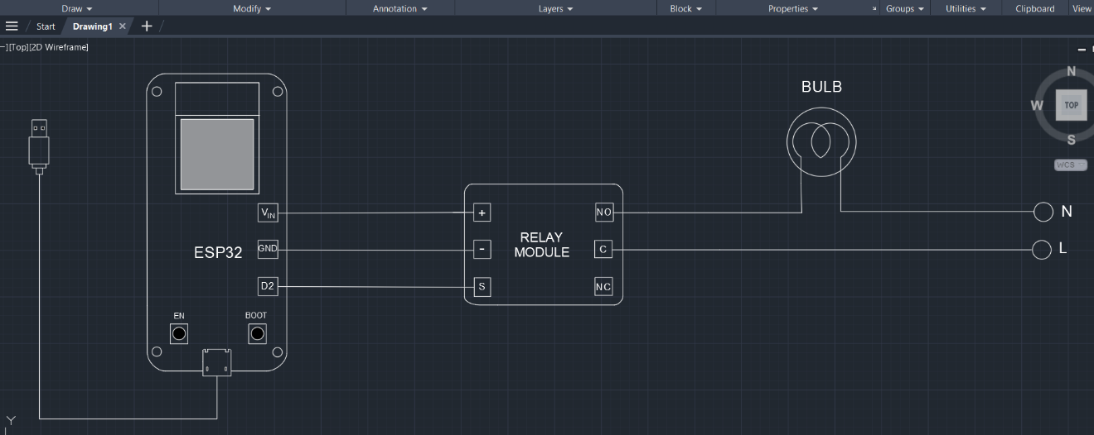
10.Circuit diagram

11.ESP Can be used for:-
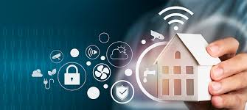

Smart homes
Industrial automation
Smart lighting systems
Remote monitoring systems
IoT learning projects
12. Conclusion
This ESP32-based IoT home automation project successfully demonstrates the implementation of a smart wireless lighting control system using modern IoT technologies. The integration of ESP32, relay module, Wi-Fi communication, and the Blynk cloud platform enables real-time remote appliance control through a mobile application.

